**TITLE**

**Anna V. Smith1, Ivan I. Ivanov1,2,\***

**1Institution name, city, state/province, country**

**2Bashkir State Medical University, Ufa, Russian Federation**

**Anna V. Smith –** academic degree,Department, orcid.org/0000-0000-0000-0000

**Ivan I. Ivanov -** Dr. Sci. (Med.), Prof., Department of Oncology, orcid.org/0000-0001-0097-0518

**\*Correspondence to:** Ivan I. Ivanov,e-mail:

**Abstract**

**Introduction.** It states the aim and necessity to perform the research.

**Materials and methods.** Materials and methods of research used in the work.

**Results.** Results of research.

**Discussion.** New and significant aspects of research.

**Conclusion.** Conclusions on the obtained results.

**Keywords:** 5-10 words

**Statement of informed consent.** Written informed consent was obtained from the patient for publication of this case report and accompanying materials.

**Conflict of interest.** The authors declare no conflict of interest.

**Contribution of the authors.** The authors contributed equally to this article

**Sponsorship data.** This work is not funded.

**INTRODUCTION**

It states the aim and necessity to perform the research and gives a short background of the issue with reference to the most significant publications. The aim of the investigation is mentioned at the end of this part.

**MATERIALS AND METHODS**

Quantitative and qualitative characteristics of the included patients (or experimental animals) are given study design, all methods of research used in the work are mentioned including those used for data processing (fig 1)*. While mentioning the equipment and new medications it is necessary to name the producer and the country of production (in brackets). The journal uses international unlicensed names (IUN) of medications.

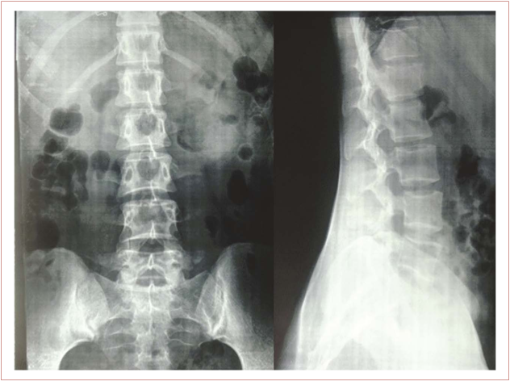

Figure 1. X-ray picture, after the treatment (10 days)

**RESULTS**

It is the main part of the article. They should be presented in a logical sequence in the text, in tables (tabl.1) and figures (fig. 2). The text shall not repeat all the data from the tables and figures, only the most important of them should be mentioned. The figures must not repeat the data of the tables.

|  |  |  |  |
| --- | --- | --- | --- |
| **Indicator** | **Constant b 0** | **AT III, %** | **D-dimers** |
| Assessment |  |  |  |
| Odds ratio (measure units) |  |  |  |
| Odds ratio (range) |  |  |  |

Table 1. Table of regression results

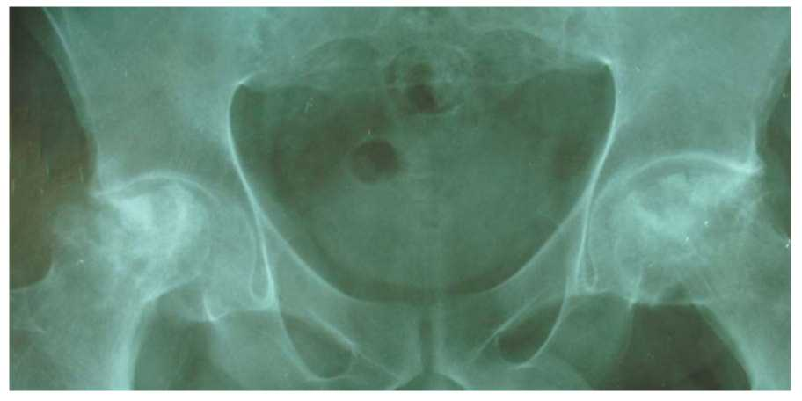

Figure 2. AVNFH with signs of prior coxarthrosis without acetabulum necrosis

**DISCUSSION**

It is necessary to point out some new and significant aspects of the research with references and if the situation allows, compare them to other researchers’ data (video 1)**. This part should be concise and definite. One should not repeat the information given in “Introduction” and detailed data from “Results”. Limitations of the study and its practical significance shall be discussed (аudio 1)***. The discussion may contain justified recommendations.

Video 1. Radiotherapy in global cancer care

Audio 1. Postoperative pain management and opioids

**CONCLUSIONS**

This part must contain short results and conclusions based on the obtained results.

**REFERENCES**

1. World health organization. Cancer [Internet]. WHO, 2018. [cited 2020 Sept 9]. Available from: <https://www.who.int/news-room/fact-sheets/detail/cancer> .
2. Forner A., Reig M., Bruix J. Hepatocellular carcinoma. Lancet 2018;391:1301–14. DOI:10.1016/S0140-6736(18)30010-2
3. Pazgan-Simon M., Simon K.A., Jarowicz E., Rotter K., Szymanek-Pasternak A., Zuwała-Jagiełło J. Hepatitis B virus treatment in hepatocellular carcinoma patients prolongs survival and reduces the risk of cancer recurrence. Clin Exp Hepatol. 2018;4(3):210-216. DOI:10.5114/ceh.2018.78127.

_____________________________________________________________________________

**\*** For **images** (photographs or photographic images) that are used as part of illustration or image composite figures we require a file that is no less than 300 dpi when set at its final printed size. Ideal file formats are TIF or JPG.

For **illustrations** (all non-photographic line-work and general drawing) we require editable vector files that contain selectable geometry and fonts (editable text).

** **Video material** should be submitted in .mp4 format with aspect ratio of 16:9, and be no larger than 250 Mb.

*** **Audio material** should be submitted as an mp3 file, no larger than 250 Mb.